Science Quest 10
Individual Pathways
Activity 3.2 Answers
Investigating evolution
Answers

- Answers for the memory aid will vary. | - Answers for the memory aid will vary.
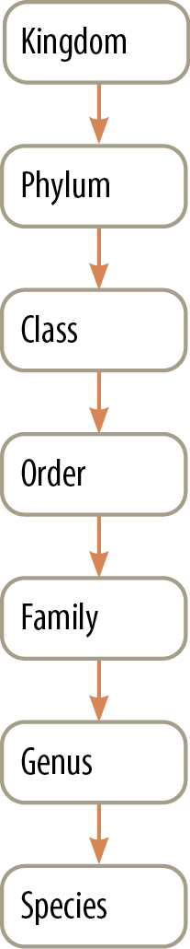 | 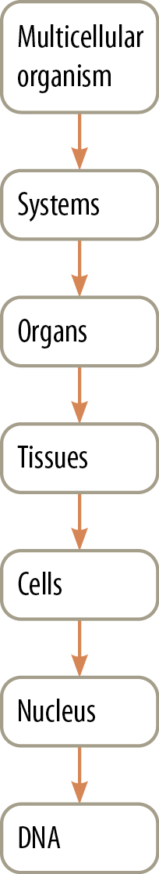

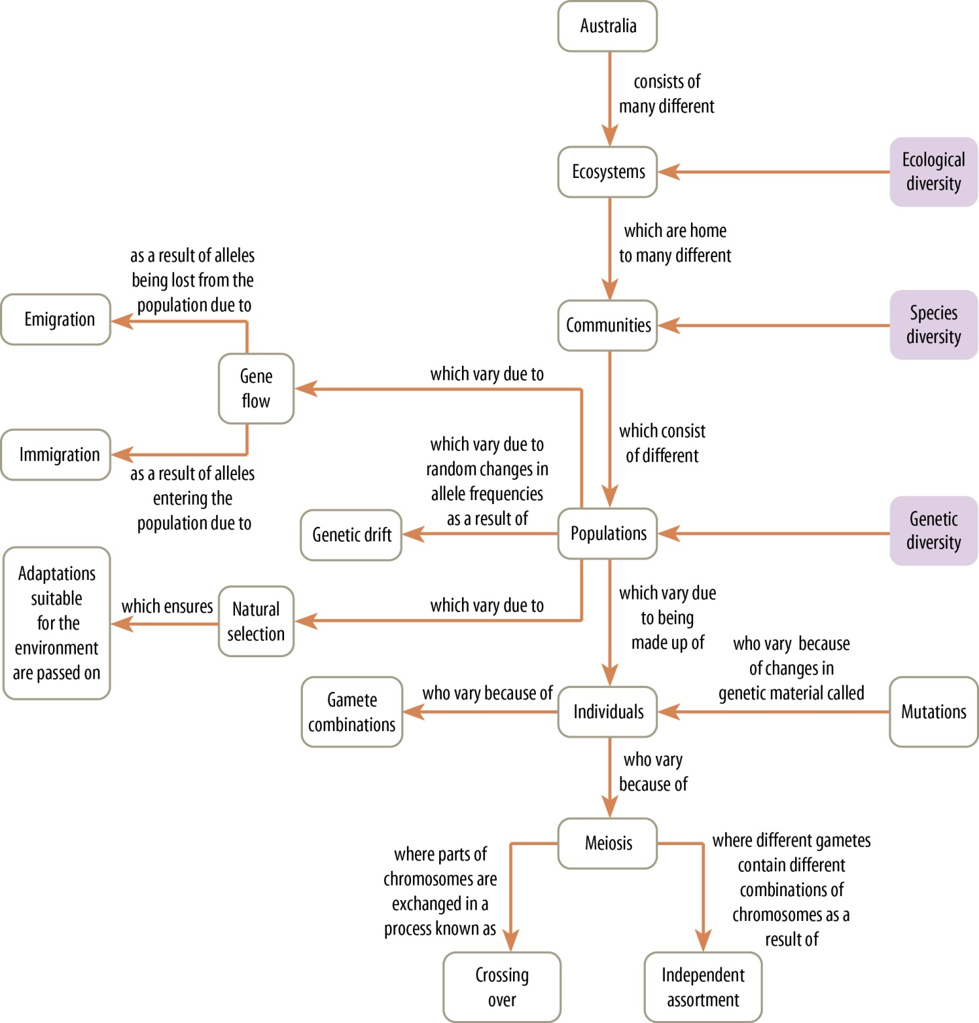

4. Answers will vary but may include the following.
Similarities | Differences
- Both decrease variation.  - Both can potentially lead to species with more suitable traits.  - Both can be influenced by the action of humans. | - Reproductive technologies are controlled and have specific goals in mind.  - The impact due to changes in the environment is usually incidental.  - Environmental change affects species diversity as species are lost.  - Reproductive technology affects genetic diversity as the variation within a population is decreased.

5.
 | D |  | A | Random mutation, natural selection and a long period of time result in the two groups becoming increasingly adapted to their particular environments and increasingly different to one another.
 | E |  | B | Speciation has occurred, resulting in two species.
 | C |  | C | The two groups are isolated from one another so breeding between the two groups ceases.
 | A |  | D | A single group of organisms within a particular species splits into two separate populations.
 | F |  | E | One population migrates to a different habitat that exerts environmental pressures different to those experienced by the original population.
 | B |  | F | Eventually, members of the two populations become so different from one another that they are no longer able to interbreed, even if brought back together again.

- Answers will vary but could include: predation, climatic factors, disease, intra-species competition and inter-species competition.

7.
- The images are examples of convergent evolution because although all the organisms possess wings and fly, they belong to very different taxonomic groups. For example, insects are arthropods (which are invertebrates) and bats are mammals (which are vertebrates). Wings have evolved due to selection pressures that make flight advantageous.
- The images are examples of divergent evolution because a range of different limbs are shown for the different vertebrates. These limbs are adapted to suit the current environment of the animal but show a similar underlying structure. This suggests the animals have shared a common ancestor at some point in time and that changes in function are the result of selection pressures specific to each animal.

Comparative anatomy involves comparing the bone structures of different organisms. Similar bone structures are referred to as homologous structures and are seen to be evidence of a common ancestor. Homologous structures provide evidence of divergent evolution as they have similar organisation but often have different functions in species as a result of different selection pressures. An example of a homologous structure is the pentadactyl limb found in mammals.
Similar features present in unrelated animals are referred to as analogous structures and result from similar selection pressures. Analogous structures provide evidence of convergent evolution because although the final function is the same, the underlying structures are not. An example would be the wings of butterflies (which are invertebrates) and birds (which are vertebrates).

 | Plate tectonics | A |  | A | The theory that suggests that the Earth’s crust is divided into plates that move. It is supported by evidence that many of Australia’s marsupials originated in South America.
 | Comparative anatomy | G |  | B | The technique of inferring evolutionary relationships by looking at the presence of fossils and current species of animals in relation to geographical regions
 | Biogeography | B |  | C | Traces of organisms that lived in a previous geological age
 | Absolute dating | E |  | D | The technique of working out the age of fossils by looking at their position in rock layers as well as referring to index fossils
 | Relative dating | D |  | E | The technique of working out the age of fossils by looking at the decay of radioisotopes
 | Molecular biology | H |  | F | The technique of inferring evolutionary relationships by studying the presence of similar features during the development of embryos
 | Comparative embryology | F |  | G | The technique for establishing evolutionary relationships by comparing bone structures
 | Fossil | C |  | H | The technique used to establish evolutionary relationships through the sequencing of DNA or proteins

- Cast: a rock with the shape of an organism protruding
- Carbon imprint: the dark print of an organism that can be seen on a rock
- Mould: a rock that has an impression (hollow) of an organism
- Whole organisms: organisms that have been preserved whole as a result of being mummified or frozen
- Amber fossils: fossils of small insects, animals or plant parts that have been trapped in sap that has solidified and become amber.
- Petrified fossils: formed when the organic material of living things has been replaced by minerals

- Devonian
- Silurian
- Jurassic

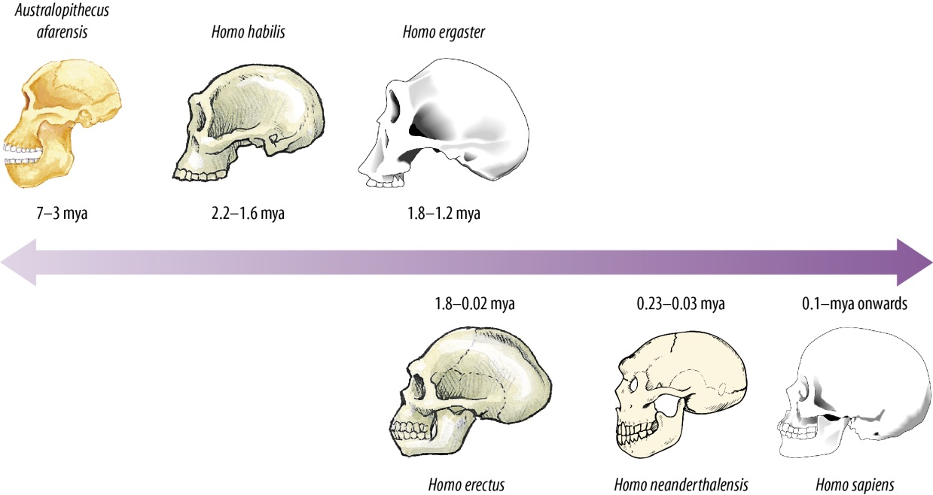

- Australopithecus afarensis, Homo habilis, Homo ergaster
- The faces become flatter as we travel forward in time.
- The size of the skull increases as we travel forward in time. This is to allow for increased brain size.

- Answers for (a)–(c) will vary, but a suitable example is Chinese giant pandas, which are endangered due to deforestation/destruction of their environment. A key step in preventing extinction is the establishment of national parks so that species numbers can be monitored.

